< Mini Project Title >

Submitted in partial fulfillment of the requirements of

**Mini Project (CSM501)**

for

Second Year of Computer Engineering

By

<Student Name> <Roll No>

<Student Name> <Roll No>

<Student Name> <Roll No>

<Student Name> <Roll No>

Under the Guidance of

Prof. <Name of Guide>

Department of Computer Engineering

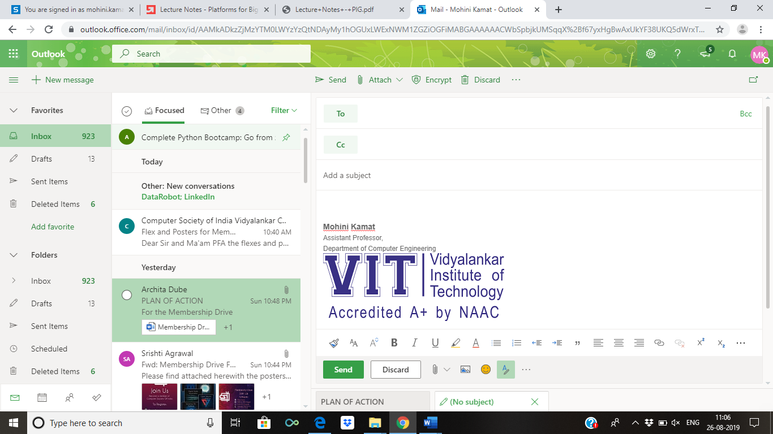

**(An Autonomous Institute Affiliated to University of Mumbai)**

Vidyalankar Institute of Technology

Wadala(E), Mumbai-400437

University of Mumbai

2022-23

**CERTIFICATE OF APPROVAL**

This is to certify that the project entitled

**“<Project Title>”**

is a bonafide work of

**<Student Name> <Roll No>**

**<Student Name> <Roll No>**

**<Student Name> <Roll No>**

**<Student Name> <Roll No>**

submitted to the University of Mumbai in partial fulfillment of

**Mini Project (CSM301)**

for

Second Year of Computer Engineering

Guide Head of Department Principal

(Name)

Mini Project Report Approval

This project report entitled <***Project Title>*** by

1. ***<Student Name> <Roll No>***
2. ***<Student Name> <Roll No>***
3. ***<Student Name> <Roll No>***
4. ***<Student Name> <Roll No>***

is approved for Mini Project (CSM301) for Second Year of Computer Engineering.

|  |  |
| --- | --- |
| Internal Examiner | External Examiner |

Date:

Place:

Declaration

I declare that this written submission represents my ideas in my own words and where others' ideas or words have been included, I have adequately cited and referenced the original sources. I also declare that I have adhered to all principles of academic honesty and integrity and have not misrepresented or fabricated or falsified any idea/data/fact/source in my submission. I understand that any violation of the above will be cause for disciplinary action by the Institute and can also evoke penal action from the sources which have thus not been properly cited or from whom proper permission has not been taken when needed.

Name of student Roll No. Signature

1)

2)

3)

4)

Date:

Place:

Acknowledgements

This Project wouldn’t have been possible without the support, assistance, and guidance of a number of people whom we would like to express our gratitude to. First, we would like to convey our gratitude and regards to our mentor **GUIDE NAME** for guiding us with his constructive and valuable feedback and for his time and efforts. It was a great privilege to work and study under his guidance.

We would like to extend our heartfelt thanks to our Head of Department, **HOD name** for overseeing this initiative which will in turn provide every Vidyalankar student a distinctive competitive edge over others.

We appreciate everyone who spared time from their busy schedules and participated in the survey. Lastly, we are extremely grateful to all those who have contributed and shared their useful insights throughout the entire process and helped us acquire the right direction during this research project.

Abstract

**Table of Contents**

|  |  |  |
| --- | --- | --- |
| **Sr No** | **Description** | **Page No** |
| 1 | Introduction |  |
| 2 | Problem Definition |  |
| 3 | Literature Survey |  |
| 4 | Conclusion |  |
| 5 | References |  |